**Language** : English **Original :** French

**ISLAMIC REPUBLIC OF MAURITANIA (RIM)**

**PROJECT: PROMOTION OF GENDER-SENSITIVE**

**AGRICULTURAL VALUE CHAINS AND WOMEN'S ENTREPRENEURSHIP IN SUPPORT OF THE PROGRAM TO SUPPORT AGRICULTURAL TRANSFORMATION IN MAURITANIA (PCVASGEF-PATAM)**

**PROPOSAL TO THE GLOBAL AGRICULTURE**

**AND FOOD SECURITY PROGRAM (GAFSP)**

Supervisor Body:

African Development Bank Group

**August 2021**

TABLE OF CONTENTS

**I. SECTION 1: BASIC DATA 1**

* 1. Project Development Objective: 2
  2. .Rationale and approach adopted in the proposal design 3
  3. Components of the proposed project 3
  4. Project area and beneficiaries 8
  5. Supply and market gaps targeted by the project 8
  6. Professionalization of socio-professional organizations 8
  7. Monitoring Results at the Proposal Stage 9
  8. Relevant of the approach and proposed activities 9
  9. Rationale for GAFSP Funding Request : 10

1. **SECTION 3: PROPOSED PROJECT CONTEXT AND POLICY FRAMEWORK : 10**
   1. Agropastoral Sector Context 10
   2. Economic Recovery Program after COVID 19 [ProPEP] 12
   3. Regional Processes 13
   4. Summary of the Rural Sector Development Strategy (RSDS) 14
2. **SECTION 4: CROSS-CUTTING THEMES 15**
   1. Selected GAFSP priority cross-cutting theme areas: 15
   2. Coverage of identified thematic focus areas 15
   3. Consistency with national policies and strategies 17
   4. Role and participation of women and girls in the project 18
3. **SECTION 5: PROJECT IMPLEMENTATION, SUSTAINABILITY AND BUDGET 18**
   1. Risks to Achieving Project Objectives 18
   2. Sustainability 19
   3. Consultation with local stakeholders and development partners 19
   4. Arrangements for the implementation of the proposed project 20
   5. Project Coordination and Partnership 20
   6. Project budget and financing 20

**CONCLUSION 21**

1. **PROJECT BUDGET TABLES 22**
2. **- PROPOSAL STAGE PERFORMANCE MONITORING MATRIX 25**
3. **- RISKS AND NEGATIVE EXTERNALITIES 30**
4. **- PROPOSAL PREPARATION TEAM 32**
5. **- MAP OF THE PROJECT INTERVENTION AREA 32**
6. **- PICTURES OF THE ACTIVITIES AND BENEFICIARIES OF THE PAHABO 32**
7. **- IMPACT OF THE PAHABO 33**
8. **- DOCUMENTARY ON PAHABO 34**

Currency equivalents

[August 2021]

Currency: New Mauritanian Ouguiya (MRU)

[1 UC] = [51,39 MRU]

[1 UC] = [1,42877 USD]

[1 USD] = [35,968 MRU]

Fiscal Year

[January 1 - December 31]  
**Weights and measures**

1 meter (m)

1 millimeter (mm)

1 kilometer (Km)

1 square kilometer (Km2)

1 are (a)

1 hectare (ha)

1 kilogram (kg)

1 metric ton

1 metric ton

3.280 feet

0.03937 inch

0.62 mile (=1,000 m)

1 000 000 m2

100 m2

2,471 ares (= 10,000 m2)

2.204 pounds

1,000 Kg

2,204 pounds

|  |  |
| --- | --- |
|  | **Acronyms and abbreviations** |
| ADRiFi AfDB WB CMP CNCP RCPC MA MEDD MAEPSP MDGs PAHABO PATAM PGES PPP | = African Disaster Risk Management Financing Program  = African Development Bank  = World Bank  = Performance Measurement Framework  = National Project Coordination Committee  = Regional Project Coordination Committee  = Ministry of Agriculture  = Ministry of Environment and Sustainable Development  = Ministry of Economic Affairs and Promotion of Productive Sectors  = Millennium Development Goals  = Hydro-agricultural development project in West Brakna  = Program to support the Transformation of Agriculture in Mauritania  = Environmental and Social Management Plan  = Public Private Partnership  Promotion of Gender-Sensitive Agricultural Value Chains and Women's |
| PCVASGEF SDSR SCAPP SONADER SYDONIA UA  EU | = Entrepreneurship  = Rural Sector Development Strategy  = Strategy for Accelerated Growth and Shared Prosperity  = National Society for Rural Development  = Automated Customs System  = Unit of Account  = European Union |

**I. Section 1: Basic Data**

|  |  |
| --- | --- |
| a. Project title | Promotion of gender-sensitive agricultural value chains and women's entrepreneurship in support of the program to support agricultural transformation in Mauritania (PCVASGEF-PATAM) |
| b. Applicant country (ies) | Mauritania |
| c. Ministry (s) responsible (s) for implementation | Ministry of Agriculture (MA) |
| d. Main country contact / Main country contact (Name, position, organization, email address)  (Names and contact information of the project preparation team members should be provided in  Annex 5) | Mohamed Ould NEMINE Charge de mission Ministere de l’Agriculture MAURITANIE  [Mohamednemine@yahoo.fr](mailto:Mohamednemine@yahoo.fr) |
| e. Total amount of funding requested from GAFSP  *(see Appendix 1 - Project Budget*  *Table)* | Amount requested : 18.71 Million USD  Minimum amount needed : 16.00 Million USD |
| f. Estimated project start and end dates: January 2023 - December 2027 | |

1. Preferred Supervisory Body

**Supervisory body for investments** : African Development Bank (AfDB)

1. Has the country (countries) ever received GAFSP funding? DYes,

complete Appendix 4 XDNo.

II Section 2: Description of the project

Our country's economy is still characterized by low diversification and a relatively fragile structure. Located in the Sahel, Mauritania has an agropastoral sector that is highly vulnerable to exogenous shocks and to the hazards of recurrent droughts. Climate change is manifested by extreme phenomena (alternating periods of drought and flooding) and the recent progression of these climate changes, manifested among other things by an increase in temperatures and a decrease in rainfall, accentuates this vulnerability. National food needs are covered mainly by imports and food aid. The best agricultural years cover less than half (40%) of food needs. Severe malnutrition continues to affect the development of many children, particularly from poor households, especially in rural areas during the lean season. The current COVID 19 pandemic, with its successive waves, has further exposed these vulnerabilities, particularly in the areas of health, food, and nutrition. The delay in rainfall during this year's rainy season, combined with the third wave of COVID 19, is likely to exacerbate precariousness in rural areas.

The Government has initiated actions to boost agriculture as part of its strategy for accelerated growth and shared prosperity (SCAPP 2016/2030). Within this framework, a National Agricultural Development Plan (PNDA 2016/2025) derived from the Rural Sector Development Strategy (SDSR) was put in place and approved in 2016 by the Council of Ministers. Following these guidelines, the Program to Support the Transformation of Agriculture in Mauritania (PATAM) got off to a good start in 2018 with the increased mobilization and support of several partners (ADB, IDB and Green Fund). The present Project for the Promotion of Gender-Sensitive Agricultural Value Chains and Women's Entrepreneurship (PCVASGEF) fits into the framework of this strategic program and supports it to contribute to the achievement of the structural transformation of agriculture in Mauritania. The assistance of the Global Agriculture and Food Security Program (GAFSP) is sought to strengthen this process, to serve as a catalyst to consolidate the gains made and consequently to contribute to the diversification and sustainable recovery of the country's economy after COVID 19 and to promote the resilience of agricultural value chains and the entrepreneurship of women and girls.

* 1. Project Development Objective:

The sectoral objective is to contribute to the improvement of food and nutritional security and the living conditions of the target populations. The expected project objective is to increase productivity, add value to agricultural products and support the empowerment and promotion of entrepreneurship of women and girls.

* 1. . Rationale and approach adopted in the proposal design

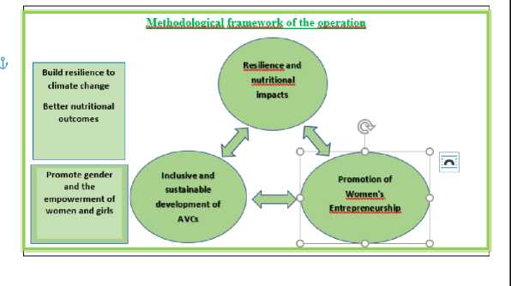The proposal adopts a holistic approach based on the interaction of the three pillars presented in the following diagram to achieve the set objectives:

1. Resilience and nutritional impacts;
2. Promotion of women’s entrepreneurship;
3. Inclusive and sustainable development of gender sensitive agricultural value chain.

2.3 Components of the proposed project

* + 1. In order to achieve its objectives, the PCVASGEF project, which is complementary to PATAM, includes the same components as PATAM, with particular emphasis on the economic empowerment of women and girls and the promotion of female entrepreneurship:

1. Structuring and resilient developments;
2. Development of value chains and youth and women entrepreneurship; and
3. Project coordination.

***Table 2.2: Project Components***

|  |  |  |  |
| --- | --- | --- | --- |
| **N°** | **Component Name** | **Estimated Cost** | **Description of the components** |
| I | Structural and resilient facilities | 11,556 Millions USD (60,37%) | * Development of women's market gardening areas (WMGA) covering an area of 1,014 ha   using a Californian type irrigation system with buried pipes (186 PMF of 4 ha along the river/flooded rivers and in the Dieri in the flooded zone, 135 PMF of 2 ha supplied from mini­bores), all the areas will be supplied by solar pumping   * Creation of fodder reserves by putting 600 ha under protection. * Recalibration of natural channels to control the filling of basins and improve flood   recession crops (4,500 ha);   * Construction of feeder roads (17 km) * Accompanying measures: Monitoring and control of the works, sensitization of the   populations and the works personnel   * Implementation of the environmental and social management plan (PGES) of the   PATAM updated by integrating the development works |
| II | Development of value chains and entrepreneurship of youth and women | 6,949 Millions USD (36,30%) | * Construction and equipment of twelve (12) integrated platforms (multi-purpose centers   for the promotion of women's activities connected to the Internet); Construction and equipment of three (3) vegetable packaging and storage units of 630 m2 of built area with a storage capacity of 80 tons; Construction and equipment of six (6) vegetable markets of 132 m2 of built area;   * Technical and management capacity building for women's cooperatives, optimal use of   platforms and development of market gardening areas, including various activities: market gardening, poultry farming, small ruminant breeding, income-generating activities, processing of agricultural products and technical training, management and structuring of women's organizations and organization of the inter-professional organization; structuring of the market gardening value chain and access to markets; |

|  |  |  |  |
| --- | --- | --- | --- |
|  |  |  | * Support for the establishment and introduction of off-ground nursery techniques and the   use of mini greenhouses for the production of seedlings in all seasons, training of nurserymen in these techniques;   * Training of eighteen (18) trainers and 24 relay farmers, as well as 1,000 cooperative   leaders; provision and use of high quality seeds; collection and dissemination of good practices in climate-smart agriculture and agroecology; (the Centre de Formation des Producteurs Ruraux-CFPR (Rural Producers Training Center), located in Bogue, will play an important role in the supervision of the beneficiaries) This center has benefited from PATAMs support to develop its reception capacity, strengthen its institutional capacities and upgrade its training program and equipment;   * Information Education and Information on nutrition and reproductive health, improving   food safety, prevention of COVID 19 and sensitization of communities on the prevention and fight against gender-based violence including female genital mutilation, early marriages, sexual and reproductive education including birth planning;   * Support for the optimal use of vegetable markets and market garden product packaging   centers and the establishment of a contractualization mechanism for cooperatives grouped in Economic Interest Groups (EIGs) or Unions with these centers (support for the aggregation and partnership process with the private sector);   * Support for land tenure security for all WMGAs and integrated platforms (regularization   and delivery of land certificates to women farmers); Facilitation of land tenure agreements in improved floodplain areas, support for the use of quality seeds and support for intermediate food crops on the banks (F alo).   * Support to the development of youth and women entrepreneurship and innovations in   market gardening (valorization of local products; promotion of solidarity trade and labels, packaging, service centers, micro-irrigation, small mechanization, etc.).   * Support for the establishment of an insurance and risk-sharing system (interaction with   the ADRIFI program approved by the Bank in 2020 to support the prevention and management of disaster risks related to climate hazards) and support for twelve (12) savings and microcredit banks to facilitate women's access to credit.   * Support for income-generating activities (fattening of small ruminants; fish farming,   poultry houses, butcheries with slaughter areas, fish farming in restored natural channels and fishmongers, vegetable dryers, small-scale processing of agricultural and animal products and small mills and eco-tourism with young people with innovative projects).   * Support to aggregation and private initiative - 4P (private integrator-private operator,   producers ...). The project will collaborate with the Chamber of Commerce, Industry and Agriculture (CCIAM) and will support the establishment of an incubator/accelerator within the CCIAM to support the entrepreneurial culture and promote young agri-preneurs through skills training over 18 months for a group of forty (40) and will explore the possibilities of linking these agri-preneurs through aggregation contracts with private investors (agro­industrialists, processors, local banks, etc.) by creating potential synergies with the BCI line of credit recently approved by the Bank in July 2021 (in the amount of €10 million) focusing on women entrepreneurs and VSEs;   * Support to marketing (strengthening of the transport system, use of crates, better   information on the markets, implementation of e-commerce, solidarity market, involvement and organization of inter-professions, support to agricultural digitalization and use of new technologies, etc.) |

aDetailed description and scope of the components

Component I-Structural and resilient facilities

* + 1. The project will focus on sustainable facilities, simple to build and operate and within the reach of the project beneficiaries. This option will make it possible to develop the existing solar and irrigation potential. The developments to be carried out will allow the control and the saving of water and will serve as a basis for the improvement of productivity. The main achievements and activities planned include: (i) the development and equipment of 1014 ha of irrigated market gardening perimeters for the benefit of women (PMF) along the Senegal River and the Dieri (high non-floodable areas); the perimeters (744 ha) supplied from the Senegal river or its tributaries, will be built in units of four (4) ha each. The cooperatives will be able to benefit from one to two sites

depending on the land available and the beneficiaries' water management capacities; the perimeters (270 ha) located in the Dieri and fed from mini-bores (depth less than 30 m) will be limited to two (2) ha due to the reduced availability of water and the capacities of the water table; (ii) the improvement of 4,500 ha of flood recession crops through the recalibration of natural channels for filling the plains and support for development to increase productivity; (iii) the construction of 17 km of feeder roads to open up specific production areas in the project intervention zone; and the creation of community fodder reserves of 600 ha (5 ha per site) through the establishment of defenses and according to the delimitations based on the land use plans available at the level of the communes. This will allow to reinforce the feeding of livestock and the good management practices of the environment and pastoral spaces (integration logic).

* + 1. Like PATAM, the project is a climate change adaptation operation and will have positive impacts on the environment. The ESMP of the PATAM program will be updated to include the project activities. This update will be done during the detailed formulation phase. Preliminary design (PD) studies for the women's market gardening areas (WMGAs) and other works may be completed before the project approval process is completed by the supervisory body (ADB). All planned development work will be contracted out. The control and supervision of the works will be entrusted to consultancy firms.
    2. The results recorded in the development of women's market gardening areas and the improvement of flood recession crops during the first phase of the hydro-agricultural development project in West Brakna (PAHABO) are considered very satisfactory with positive impacts on the quality of life of the beneficiaries. Thus, the presence of water during the cold off-season in the vicinity of land used for mixed farming has made it possible to initiate the development of women's market gardening areas (WMGA). The realization of the WMGAs will make it possible to supplement the food bowl of the zone where the populations produce mainly cereals (rice and sorghum). These good experiences will be capitalized and scaled up within the framework of the proposed project. During the consultations held during the formulation of the project, the women insisted on market gardening, fish farming, small ruminant fattening and poultry farming. They emphasized the very important contribution of these activities both in terms of employment and as sources of income for households. The self-consumption of these products will improve the nutritional status of the populations in the project area. The construction of a wire fence and the planting of a living hedge (windbreak) are planned around each WMGA unit. Within the framework of the project, small California system irrigation units of 4 ha will be developed along the Senegal River and its tributaries and a GMP with sufficient flow will be provided to supply these units. In Dieri, it will be necessary to develop Californian perimeters of 2 ha supplied from mini-bores not exceeding 30 m in depth. All the perimeters will be supplied with water by solar pumps. This will reduce production costs by saving on diesel costs. The project will promote the dissemination of the use of solar pumps on a large scale in order to contribute to the reduction of greenhouse gases.
    3. Another lesson learned from PAHABO concerns the improvement of flood recession crops, which has had spectacular impacts in the zone with the return of nearly 1,500 households from the city to the West Brakna zone. Indeed, the restoration of ecosystems and natural conditions for filling flood basins has led to an increase in food production and income with positive effects on the improvement of housing, accessibility, and the environment. This good practice of sustainable development will be adopted by the project, which also provides for better control of the water bodies in the channels to maintain water for a longer period of time in the off-season and thus allow for fish farming and small-scale irrigation activities.

Component II - Development of value chains and entrepreneurship of youth and women

* + 1. The main objective of this component is to strengthen the technical and organizational capacities of the actors of the value chains, to support entrepreneurship, to carry out and manage in an optimal way the investments in order to reinforce the economic empowerment of women and girls and to valorize the agricultural products. The main activities under this component are:

1. The construction and equipping of twelve (12) integrated platforms (multipurpose centers for women's advancement). These are dedicated platforms and spaces grouping all the activities of women. These platforms have a built area of 317 m2 and are composed of two offices; 1 equipped training room (production, productivity, management, CV, nutrition, computers and access to the internet and the market information system); 1 room with equipment for processing agricultural products; 1 community store; 1 exhibition room for products intended for sale; 1 store and 1 community daycare center for children; a 150 m2 playground will complete the system. These platforms will serve as information, education and communication spaces on all themes specific to women.
2. The construction and equipment of three (3) vegetable packaging and storage units with a unit capacity of (80 T), like the center being equipped in Bogue, each center will be composed of a block of offices with a built area of 105 m2 and another main block of technical premises (two packaging rooms, a pre-cooling room and four cold chambers of +4°C) on a useful built area of 525 m2 for a total floor area of 570 m2.
3. The construction and equipment of six (6) vegetable markets, each consisting of eight (8) stores with a built area of 84 m2, a 48 m2 stall shed and amenities (two restaurants and a battery of public latrines).
4. Securing land tenure in the WMGAs for their optimal development and the autonomous management of the integrated platforms; the project will promote, with the support of the Ministry of Agriculture's land tenure unit, the regularization and allocation of land and eventually land certificates to women's cooperatives; an agreement will be negotiated and signed with this structure; the project will provide support for the establishment of land tenure agreements in the improved flood plains; legal support to cooperatives and farmers will be provided upon request.
5. Strengthening the technical and management capacities of women's cooperatives : training of 1,000 leaders of 200 cooperatives, 18 trainers and 24 relay farmers; provision and use of high quality seeds; Training in crop diversification and intensification; dissemination of good irrigation practices, climate-smart agriculture and agroecology; structuring of the market gardening value chain; training of nurserymen; technical guides (400 copies) of the main crops and commodity chains, resulting from available research and translated into national languages and structuring of cooperatives, MSEs and inter-professional organizations of the market gardening sector; support for the establishment of an efficient WMGA management system. The project will use an NGO specialized in this field and also the services of consultants specialized in the agricultural value chain and nutrition. Specific training sessions adapted to the needs of women will be planned and organized in relation to the Bogue Rural Producers' Training Center (CFPR), which has benefited from PATAM's support for its upgrading.
6. The establishment and strengthening of twelve (12) savings and loan banks with the support of the national Union of oasis and rainfed credit mutuals (UNMICO); an institutional support agreement will be negotiated with this network for this support in synergy with the actions underway within the framework of PATAM concerning the establishment of a Guarantee Fund and the promotion of agricultural insurance.

(vii) Support for the processing and marketing of products through the structuring of Value Chains (VC) and inter-professional actors to allow for better coordination of crop plans and compliance with crop calendars; better marketing of products and regulation of markets; and the establishment of a mechanism to determine the promising sectors according to the seasons as well as the_competitiveness and potential of traditional vegetable varieties during periods of low vegetable production in the dry season; Training on the processing of agricultural products and a consultant specialized in VC will support the project in the realization of the training plan and the implementation of this activity, acquisition of machines for the processing of cereals and vegetables, granting of processing machines and conservation rooms; Support for the optimal operation of vegetable markets and packaging centers for market garden products and establishment of a contractualization mechanism for cooperatives with these centers. The project will collaborate with the Chamber of Commerce, Industry and Agriculture (CCIAM) in partnership with the Young Economic Chamber for the establishment of an incubator for young agripreneurs. It will assist in the training of 40 agripreneurs (18 months) and support them in their projects to initiate the development of export-oriented sectors with a view to free trade on the continent.

1. Support to income-generating activities (6 small processing units, 12 vegetable dryers, 20 small mills, small ruminant fattening, 6 small cow milk processing units, 2 butcheries/fishmongers with solar fridges; fish farming in restored channels and 14 chicken coops with a solar-powered shed, a store and two solar fridges)
2. Promotion, training and financing of youth and women's entrepreneurship and innovations in market gardening value chains to support, in addition to PATAM, innovative projects of youth and women and the establishment of start-ups to be selected (valorization of local products (4), mechanical workshops (4), agricultural service providers (4), young agripreneurs in very small­scale irrigation and processing (40) and other innovative initiatives in the VC (52), particularly in small-scale mechanization, input supply, marketing, label promotion and packaging. The project will promote the exploitation by young agripreneurs in the off-season of micro perimeters along the feeder channels of the recession basins. These activities will be coordinated with the regional agency of ANAPEJ/TECHGHIL in charge of the promotion of youth employment already in place in Bogue to promote local services.

Component III -Project Coordination

2.3.7 The option chosen is to reduce transaction costs and to integrate the proposed project into existing structures. Thus, the coordination of activities will be ensured by the PATAM team already in place in the premises of the Regional Directorate of the National Society for Rural Development (SONADER) in Bogue. This team effectively manages the PATAM funded by the AfDB Group and other partners. The main activities of this component are:

1. Institutional capacity building. The project will provide support to enable women's cooperatives and rural institutions to access the Agricultural Market Information System (AMIS) set up by the Directorate in charge of agricultural statistics.
2. Project coordination. In collaboration with SONADER, the PCVASGEF project will recruit two experts in Agri-business/Marketing/Commerce and Agri-food Industry/Value Chain and will strengthen the support staff at the grassroots level (two supervisors and eight (8) AVBs,

including four (4) rural advisors and animators). The project will provide support for the functioning of the coordination unit and will provide for an annual financial audit and an environmental audit.

* 1. Project area and beneficiaries

The proposed project will cover the Brakna and Trarza regions. These regions are still characterized by pockets of poverty. There are production deficits during the year and the dry season, which increases the vulnerability of households, affecting women, who represent 52% of the population, and their children. The activities of the population are essentially agropastoral. The project targets mainly women farmers and young people (60%) who are potential entrepreneurs with innovative initiatives in the agricultural value chain (innovative start-ups). Young people representing 60% of the population are also targeted in the framework of entrepreneurship development. The young beneficiaries of the project will be retained after a competitive process. They will be trained and accompanied by the project. The improvements in flood recession farming initiated in West Brakna, which have produced satisfactory results, will be continued and scaled up. The women's cooperatives concerned (19,222 members) are currently cultivating market gardens on an area of 1,062 ha (with very small farms averaging 552 m2 per woman). The realization of the project will make it possible to multiply by two the size of the exploitations of the beneficiaries and will give satisfaction to the request for extension of the WMGAs which constitute the first priority among the needs expressed by the women having accumulated an experience and a confirmed know-how. This will constitute a qualitative leap in the improvement of incomes and living conditions, the strengthening of food security and the resilience of households. Thus, the project will directly benefit to a total of 22,222 households (including the other project activities), and indirectly nearly 90,000 people.

* 1. Supply and market gaps targeted by the project

In terms of food and nutritional security, severe acute malnutrition remains, particularly for rural households whose livelihoods are based mainly on agricultural production, which face a very difficult situation of depletion of their food stocks for 4-6 months each year. During this period, known as the lean season, the availability of food products is ensured by the market. Vegetable needs are not covered by national production. There are significant volumes of vegetable imports (106,000 Tons in 2018) from Morocco and Senegal. There are relevant opportunities for substitution to these imports to be exploited by the project. The first wave of COVID 19 led to difficulties in supplying the country with vegetables and a rise in prices in the project intervention area. The Government decided to revive horticulture and to give priority to the sector to ensure better regulation between supply and demand. This project is part of this framework and will help strengthen the resilience of beneficiary households and meet the growing demand in urban centers.

* 1. Professionalization of socio-professional organizations

Women's cooperatives have limited technical and management capacities and their difficulty in accessing land remains. In the PATAM zone, there is only one vegetable packaging and storage unit that is being equipped and is not yet operational. The conditions for transporting and selling vegetables do not meet the standards needed to ensure the required product quality. The project will place particular emphasis on capacity building and securing the land of cooperatives and plans to build packaging units and vegetable markets to remedy the shortcomings noted and promote value chains and marketing beyond the area (to the capital Nouakchott). The project will support the professionalization of small family farms and the structuring of the inter-professional sector, in 8

addition to the measures recently taken by the Government to attract the private sector within the framework of the public/private partnership to be set up by recommending support for the aggregation process. The project will eventually contribute to establishing the conditions for inclusive and sustainable development, which will ensure the success of future PPPs that can be achieved in a favorable business climate and according to a contractual approach through aggregation contracts between aggregators and agents and socio-institutional support to be provided by the project.

* 1. Monitoring Results at the Proposal Stage
     1. The main achievement indicators for the proposed project are: (i) the area developed and improved in women's market gardening areas (WMGA) and improved flood recession crops in ha; (ii) the levels of agricultural intensification of WMGA; (iii) the number of km of feeder roads built; (iv) average vegetable yields obtained on WMGAs and improved flood recession food crops; and (v) additional vegetable and food crop production; (vi) number of women farmers benefiting from WMGAs; (vii) number of trainers, relay farmers and cooperative leaders trained; (viii) the number of smallholders trained in climate-smart agriculture; (ix) the number of rural institutions and women's vegetable cooperatives in operation and the number of members; (x) the number of entrepreneurs trained, financed, set up and accompanied by the project; (xi) the equipment provided to support income-generating activities; (xii) the number of AVC infrastructures (packaging unit and vegetable markets, etc. ) achieved; and (xiii) the number of decent and sustainable jobs created. The main impact indicators are: (i) improvement in the agricultural income of the target populations; (ii) contribution to food security; (iii) contribution to the improvement of nutritional status; and (iv) contribution to the reduction of food imports (in tons of market garden produce).
     2. The main sources of data for monitoring these level 1 and 2 indicators are the Project Coordination, the Directorate in charge of statistics at the MA, the National Agency for Statistics and Demography (ANSA), the CSA (Food Security Commission), the World Food Program (WFP), the Inter State Committee for Drought Control in Sahel (CILSS) Harmonized Framework (CH), the BCM (Central Bank of Mauritania), and the SYDONIA (Automated Customs System). These data will be supplemented by field surveys and targeted analyses, with ad hoc support from technical assistance as needed. Relevant data will be collected, processed and results made available through the results-based monitoring and evaluation system already established by PATAM. Semi-annual reports will be prepared and submitted to GAFSP. External monitoring will be carried out by the mandated departments of the Ministry of Agriculture (MA) and the Ministry of Economic Affairs and Promotion of the Productive Sectors (MAEPSP) in addition to the two supervision missions to be organized annually by the African Development Bank, the project's supervisory body. The project will provide support to cooperatives and AVC actors to enable them to carry out a self­evaluation of the actions implemented. The baseline situation will be established prior to the launch of the project. A mid-term review and a final evaluation will be carried out to allow for possible readjustments, to draw lessons and experiences and to capitalize on the achievements.
  2. Relevant of the approach and proposed activities

The proposal takes into account the rich experience in the development of small-scale irrigation and in the agro-pastoral sector in Mauritania and in the Sahel. It complements, continues and consolidates the ongoing Program of Support for the Transformation of Agriculture in Mauritania (PATAM), of which the project is a part. It plans to scale up the conclusive results and achievements of previous operations in Mauritania, in particular those of the Brakna Ouest hydro-

agricultural development project -PAHABO (development of women's irrigated areas, organization of beneficiaries and women's cooperatives, land regularization, implementation of an optimal scheme for developing water resources and improving flood recession crops). The experiences, lessons and strategic approaches of the supervising entity in the field of value chains (VC) and gender were well taken into account in the project design. A comprehensive and holistic approach to the entire AVC (from production to distribution) was adopted in the project design.

* 1. Rationale for GAFSP Funding Request :

COVID 19 has had significant impacts on the country's economy, which entered a recession in 2020. It has also increased the vulnerability of households in rural areas, particularly for women and children. The pandemic has also signaled the urgent need to ensure food sovereignty in the country and to take strong measures to mitigate the impacts of climate change. The women's cooperatives are looking forward to the implementation of the project that will address their main concerns. The Government is placing the proposed project within this perspective of structural transformation of agriculture, as well as the promotion, diversification and valorization of the potential of the agro­pastoral sector. The proposed project also takes into account the priority cross-cutting aspects of the GAFSP, namely the promotion of gender equality, the empowerment of women and girls, the strengthening of climate resilience, job creation, and support for women's and youth entrepreneurship and small family farms with a view to the food security of the target populations and the development of agricultural value chains. GAFSP's expected contribution will accelerate the process of strengthening the market gardening sector in Mauritania and promote more inclusive development. It will support, with concessional resources, the efforts of the Government and households to revive the country's economy after COVID 19.

III Section 3: Proposed Project Context and Policy Framework :

* 1. Agropastoral Sector Context
     1. Mauritania has significant agricultural potential in the Senegal River Valley. Extensive livestock farming and flood recession and rainfed crops are the main activities of rural populations. Despite this potential, the Mauritanian economy is highly vulnerable to exogenous shocks and to the hazards of climate change. In terms of human development, Mauritania is among the least developed countries.
     2. Overall, the country's economic growth has remained fairly weak and has not been able to significantly reduce the level of poverty, which still affects nearly one-third of the population, nor has it been able to stimulate inclusive and sustainable growth. The country is experiencing a high level of urbanization linked to the rural exodus resulting from the degradation of natural resources, climate change and precarious living conditions, particularly in rural areas. The situation has become even more difficult because of the COVID 19 pandemic, which has led the country's economy into recession (-1.5% in 2020). The management of the extractive industries, which generate few jobs, compromises the diversification of the economy. To remedy this situation, the Program to Support the Transformation of Agriculture in Mauritania (PATAM) has been launched with a view to contributing further to the revival and structural transformation of agriculture in Mauritania and, consequently, to economic diversification and inclusive growth and the formation of balanced regional development hubs.
     3. With regard to food and nutritional security, progress has been made thanks to the Government's efforts. However, this progress is still insufficient in relation to the complexity and scale of the challenges. Severe acute malnutrition remains a concern. The survey conducted in 10

September 2020 under the supervision of the Harmonized Framework (CH/CILSS Dec 2020) for the analysis and identification of risk areas and food insecure populations in the Sahel and West Africa concluded that 14.8% of the country's households (178,139) are food insecure, including 12.7% in the moderate form and 2.1% in the severe form.

^ Potential of the agricultural sector

* + 1. Mauritania has a limited agricultural area of 2.2 million hectares of UAA (Useful Agricultural Area), which is only 2 percent of the total land area. Despite the significant potential available, the agro-pastoral sector remains characterized by a low level of performance. Agriculture and livestock farming are predominantly extensive, with relatively low levels of productivity and production. Nearly two-thirds of the population derive their income mainly from these two activities. The development of agropastoral value chains constitutes an important job creation niche, particularly for young people, who represent 60% of the population. Farmers mainly grow rainfed and flood recession crops with very low yields. There is a production deficit of more than 50% of food needs and nearly 15% of households are food insecure (2020).
    2. In the country, there are four agro-ecological zones with specific natural and productive potentialities: (i) the arid zone, (ii) the Sahelian zone, (iii) the river valley zone and (iv) the maritime zone. Thus, the potential for arable land is approximately 513,000 ha, of which 350,000 ha are under extensive traditional cultivation (rainfed and flooded). Rainfed cultivation is practiced in the south, southeast, center and east of the country. These traditional crops cover 250,000 ha in the highlands of the Dieri; 60,000 ha behind dams and lowlands; and 40,000 ha under natural and controlled recession. Irrigated agriculture is essentially concentrated in the river valley, where the easily irrigated potential is estimated at 135,000 ha. In the oasis sector, which is located mainly in the regions of Adrar, Tagant, Assaba and the two Hodhs, the cultivable potential is about 16,000 ha. Finally, about 12,000 ha are exploitable for market gardening along the coast.
    3. The five main production systems, depending on the agro-ecological zones, are: (i) irrigated agriculture with total water control, which is the most developed and most productive system, (ii) the extensive rainfed cultivation system in the exundated and sandy zone or "Dieri", (iii) the cultivation system behind dams and lowlands, (iv) the natural or controlled flooding systems of the Walo, and (v) the oasis system.) Indeed, the development of the agricultural sector has resulted in the implementation of a vast short, medium and long term program, based on the new development strategy for the sector up to 2025. This program has resulted, among other things, in an increase in hydro-agricultural developments, the implementation of structuring projects and the exploitation of surface water (dams and dykes). The areas sown during the 2020/2021 season reached 315,149 ha (i.e. 61.43% of the potential cultivable land) including 165,166 ha of Dieri crops; 54,041 ha of lowlands; 21,080 ha of natural and controlled recession; and 74,862 ha irrigated (Wintering: 40,604 ha, Counter Hot Season (CHS): 33,851 ha and Counter Cold Season (CCS): 407 ha).
    4. The analysis of recent data shows that the irrigated areas have increased with relatively satisfactory yields (4.4 T/ha of rice in wintering and 5.5 T/ha in CCS). The cultivable potential is 61% developed with low productivity (average yield of all crops combined of 1.5 T/ha), particularly for traditional crops (400 to 800 kg/ha). There are efforts to be made to improve the productivity of traditional crops (improvement of seed quality, association of leguminous crops and fodder crops, access to suitable farming equipment, good practices of Water and Soil Conservation/Soil Defence and Restoration (CES/DRS), improved and controlled flooding following the example of the implementation of the hydraulic scheme of the West Brakna Hydro-Agricultural Development Project (PAHABO), etc.).

^Constraints of the Agropastoral Sector

* + 1. Despite its natural assets, the country's agriculture faces certain constraints: (i) natural: it remains dependent on climatic hazards and is considered a high-risk sector in the absence of a risk­sharing and agricultural insurance mechanism; (ii) structural: regional disparities are very marked in the distribution of cultivable land. (iii) economic: land productivity and yields are still relatively low, which does not allow for the generation of sufficient agricultural income, investment capacity remains limited, there is insufficient financing for the sector and the private sector is not very attractive; (iv) restrictive land tenure structure and status, a traditional rural land tenure system that does not provide much incentive for investors, and land tenure insecurity.
    2. There is also the weak capacity of agricultural research and advisory structures and limited adoption of innovations. Mauritanian agriculture still uses few fertilizers and phytosanitary products for crop production. The same is true for veterinary products and livestock feed for livestock production. The constraints are related to: i) the absence of high productivity technical itineraries; ii) the unavailability of specific inputs; iii) the adoption of extensive practices by producers. Despite the country's physical and socio-economic assets, the agro-pastoral sector still faces a low rate of intensification and a low rate of use of equipment and unskilled labor. The management capacities of socio-professional organizations and the inter-professional sector remain limited. Mauritanian agriculture is mainly rainfed (only about 10% of cultivated areas are irrigated). It remains largely vulnerable to climate change and extreme events (alternating periods of drought and flooding). The sectors are poorly structured and the actors in these sectors are not well organized. The interaction between the upstream and downstream sectors is very weak and the development and processing of agricultural products remains very limited in order to capture the value at the local level and generate the required development dynamics. Despite the potential, storage, packaging, marketing and access to markets are major constraints to triggering these dynamics. The project aims to improve productivity through water management, to strengthen the capacities of cooperatives and stakeholders and to add value to products in the value chain. It will thus make it possible to remove the main constraints of the sector in its area of intervention.
  1. Economic Recovery Program after COVID 19 [ProPEP]

(www .economie.gov/publications/ProPEP)

* + 1. In addition to the health implications, COVID 19 has had negative impacts on the economic and social environment. The planned economic growth in 2020 (6.3%) has evolved into a recession. A multisectoral national contingency plan was implemented. The pandemic has highlighted the inadequacy of socio-economic infrastructures and the poor development of agro-pastoral potential. In addition to the emergency, an expanded priority program of the President of the Republic (ProPEP September 2020) with a cost of 24.16 billion MRU has been developed and implemented over a period of 30 months. The program is structured around six (6) areas (see ProPEP pages 5 and 10): (i) Development of infrastructure to support growth; (ii) Improvement of social supply and support for demand; (iii) Development of the potential of the productive sectors and acceleration of the achievement of food self-sufficiency; (iv) Support for the private sector (formal and informal); (v) Reforestation, job creation; and (vi) Governance and implementation of the recovery program.
    2. The actions under Axis III of the ProPEP concern the development of fisheries potential (MRU 3907 million) and the strengthening of agropastoral potential (MRU 1515 million, i.e. 6.25% of the total budget). Among other things, it is planned to create a wholesale fruit and vegetable market in Nouakchott (PK17), to set up poultry parent farms and to protect 300 km of fencing in cultivated areas. Axis 1 also includes important rural infrastructure, including the acceleration of the electrification of production areas (250 km of lines in the valley). Among the reforms to accompany the recovery plan, it is planned to protect national market garden production, protect national poultry production, create a rural sector financing system (insurance bank, guarantee and subsidy fund) and set up a structured and inclusive public/private dialogue platform.

**The project has among its specific objectives the improvement of agricultural productivity. It is therefore well aligned and consistent with the orientations of axis 3 of the priority program for economic recovery, which aims to further develop the productive potential in order to accelerate the achievement of food self-sufficiency and create added value by sustainably strengthening the productivity and competitiveness of the productive sectors (see page 5 of the ProPEP). The proposed project will also benefit from the electrification program and the reforms envisaged under the recovery plan.**

* 1. Regional Processes
     1. In addition, Mauritania is member of the Inter state Committee for Drought Control in Sahel (CILSS) and is committed to the New Partnership for Africa's Development (NEPAD) process with its Comprehensive Africa Agriculture Development Program (CAADP), whose main objective is to accelerate agricultural growth, reduce poverty, and ensure food and nutritional security on the continent. The main measures taken can be summarized as follows
* *Institutional developments and prospects*: Reorganization of the Ministry, development of a strategy for the development of the agricultural sector with an agricultural orientation law and a National Development Plan.
* *Strengthening the availability and accessibility of quality seeds*: Initiation of a development program for the seed industry.
* *Adapted and accessible mechanization of agricultural activities*: Exemption of agricultural equipment and establishment of a credit line for its acquisition
* *Establishment of an adapted and inclusive financing mechanism*: Creation of a structure

dedicated to agricultural credit (CAM);

* *Improvement of professional organization and access to knowledge and technological*

*innovations*: Launching of ambitious training programs through the reopening of the Kaedi Agricultural Training and Extension School and implementation of research programs

* *Sustainability of agricultural developments and adaptation to climate change*: Implementation of rehabilitation programs for village agricultural perimeters and systematic reforestation of developed perimeters. Introduction of good agricultural practices.
* *Securing and managing access to land: Establishment of an inter-ministerial technical committee in charge of land*.
* *Promotion of key sectors, value chains and marketing: more specifically, the rice, market garden and forage sectors*.
* *Facilitation of access to markets:* Better access to agricultural inputs and markets;
* *The priority agricultural investment plan,* the PNDA, focuses on priority structural and productive investments.
  + 1. The country is subject to extreme phenomena linked to climate change and for this reason the Bank has supported on 2020 the establishment of a national operation in Mauritania as part of the regional program (African Disaster Risk Management Financing Program-ADRiFi) to provide technical and institutional support in the prevention and management of disaster risks linked to climate hazards, in particular droughts. ADRiFi is part of a process of strengthening resilience and the fight against food insecurity in Mauritania, which is likely to worsen in the context of Covid-19. ADRiFi plans to promote index insurance against drought risks with the Pan-African Risk Management Mutual (African Risk Capacity - ARC). The proposal will interact and enhance the achievements of ADRiFi.
    2. The results achieved through these regional processes are consistent with and aligned with the NEPAD CAADP options and prepare well for the transition to the African free trade market.
  1. Summary of the Rural Sector Development Strategy (RSDS)
     1. In accordance with the priorities announced in the Strategy for Accelerated Growth and Shared Prosperity (**[www.economie.gov/publications/SCAPP](http://www.economie.gov/publications/SCAPP)**), the overall development objective for the sector is to reduce rural poverty through equitable and sustainable economic and social development, guaranteeing food security for the population and sustainable management of natural resources. To achieve this objective, four orientations have been adopted by the Rural Sector Development Strategy (SDSR) together with an Agropastoral Orientation Law (LOA), namely (i) promote the growth of the sector to ensure the country's food security; (ii) ensure equitable access to the sector's resources; (iii) increase the supply and availability of public goods and services necessary for the sustainable development of the sector; and (iv) develop the management capacities for participatory and sustainable development.
     2. The SDSR determines the conditions for developing the country's agro-pastoral potential and natural resources. The aim is not only to contribute to poverty reduction and food security objectives as defined by the National Food Security Strategy (SNSA) updated in March 2012, but also to meet the needs of national and regional markets by 2025. To achieve this, a National Agricultural Development Plan and a National Livestock Development Plan have been developed based on the SRHR for the period up to 2025.

> Strategic axes (5) of the SDSR ([www.agriculture.gov.mr/politique](http://www.agriculture.gov.mr/politique) agricole/SDSR page39)

* **1/Promotion of livestock**: Promotion of an intensive and competitive livestock sector through the privileged development of animal sectors and the development of extensive livestock through the sustainable management of natural resources;
* **2/Promotion of agriculture**: Promotion of a competitive agriculture by the promotion and the development of the vegetable sectors with strong growth potentialities;
* **3/Local development for a competitive agriculture:** Reinforced support to local development by shifting from subsistence agriculture to competitive animal and plant production;
* **4/Participatory management of natural resources**: The development of agricultural sectors (agriculture and livestock) implies improving physical accessibility to natural resources on the one hand and using them more efficiently on the other; and
* 5/ **Appropriate legal framework** for the efficient implementation of the strategy.

**Strategic areas (5) of support to the SDSR**: Infrastructure; Agricultural and Livestock Research; Agricultural and Rural Consulting; Rural Sector Financing and Trade.

**The project's activities, which focus on the construction of resilient irrigation facilities and infrastructure for the development of the market gardening sector, are well articulated and aligned with all of the strategy's areas and substantially with areas 2/Agricultural promotion and 3/Local development for competitive agriculture.**

1. Section 4: Cross-cutting themes
   1. Selected GAFSP priority cross-cutting theme areas:
2. Gender and the empowerment of women and girls
3. Climate resilience
4. Better nutritional outcomes
   1. Coverage of identified thematic focus areas

^ Gender and women's and girls' empowerment

* + 1. . Rural women represent 52% of the population and play an important role in household socioeconomic development. They play an important role in the production of staple foods, livestock (poultry, sheep, goats, etc.), the provision of labor for harvesting and post-harvest activities. The main employment niche for women is trade, as well as handicrafts (especially leather and wool work). Women form production cooperatives in the form of microenterprises to better cope with difficulties in accessing resources and markets. They are very active in the market gardening sector. However, they are the most affected by vulnerability due to a high rate of poverty, illiteracy and unemployment. They have less access to information. Gender inequalities lead to disparities between men and women, as well as constraints related to the economic and social inclusion of women.
    2. Mauritania is located in the Sahel, which has been marked for decades by recurrent droughts. Vulnerability to climate change affects all sectors and impacts the already precarious socioeconomic conditions, resulting in a continuous need for assistance for many drought-stricken populations. The COVID 19 pandemic has made the situation even more difficult.

^ Nutritional status of target populations

* + 1. There are still large variations in the nutritional status of households from one year to the next and from one season to the next due to the climatic hazards that affect the predominantly extensive production systems that remain dependent on the level of rainfall. The depletion of food stocks in the dry season (lean season) affects the nutritional status of poor and vulnerable households and has repercussions on children's health. There are still cases of severe food insecurity, especially in villages and camps that do not have an irrigated perimeter or enough land to meet their needs. Indeed, the cognitive development of children is linked to their nutritional status, and a deficient nutritional status has negative repercussions on health status, human capital formation and economic productivity. Ensuring good nutrition for children is therefore essential. The project will make a significant contribution to this.
  1. Consistency with national policies and strategies

^ Gender and empowerment of women and girls

* + 1. The Accelerated Growth and Shared Prosperity Strategy (SCAPP), a reference document for economic and social development, provides guidelines for inclusive and equitable development. This orientation is taken up in the SRHR, which emphasizes the empowerment of women and the better consideration of gender in the development of the agro-pastoral sector in accordance with the national gender institutionalization strategy (SNIG) of the Ministry of Social Affairs, Children and Family (MASEF) (**[www.masef.gov.mr/strategiesSNIG](http://www.masef.gov.mr/strategiesSNIG) pages 24 and 25**). The project design was based on these orientations to support women's economic empowerment and the promotion of youth entrepreneurship.

^ Climate Resilience

* + 1. To address vulnerability to climate change, Mauritania has developed the necessary strategic and legislative instruments (National Sustainable Development Strategy, National Climate Change Adaptation Plan, Environmental Code, etc.). (**See [www.environnement.gov.mr](http://www.environnement.gov.mr/) / strategies and policy**) In 2015, Mauritania developed its National Determined Contribution (NDC) to meet its international commitments in accordance with the United Nations Framework Convention on Climate Change. This NDC is currently being updated.
    2. The project, which is ecologically viable, therefore aims to reduce this vulnerability for the beneficiary households. Indeed, the project, which is in itself an adaptation operation, will have positive impacts on the mitigation of climate change effects. The project will develop irrigated market gardening areas surrounded by hedges, control water to make crops more productive and less subject to climatic hazards, develop renewable energy sources (solar pumps and refrigeration), promote the use of underground irrigation techniques that are more economical in terms of water, and promote climate-smart agriculture (CSA) practices; Agroecology and integration of agriculture and livestock through the valorization of agricultural residues and the use of organic manure. The capacity building program for cooperatives will specify the number of women farmers who have received training in AIC, which will be closely monitored by the project team in accordance with GAFSP guidelines.
    3. With regard to environmental aspects, the project supports PATAM, which has been the subject of an environmental and social impact study accompanied by an environmental and social management plan currently being implemented in partnership with the Department for the Protection and Restoration of Species and Environments (DPREM) of the Ministry of the Environment and Sustainable Development (MEDD). These studies show major positive impacts on the relative environment (control of small-scale irrigation and production systems, better management of water and soil resources, production enhancement and capacity building of stakeholders). The negative impacts are not substantial and remain specific; they are nuisances around the infrastructure construction zones, small-scale land clearing, possible water and soil pollution linked to the use of particular inputs, etc.

^ Improvement of the nutritional status of the target populations

* + 1. The project, whose objective is to improve food and nutritional security, is in line with the National Food Security Strategy (NFSS - SNSA), the SDSR and, at the multisectoral level, with the national health development plan. Indeed, the food availability induced by the development of market gardening areas in all seasons and food crops associated with small-scale livestock and fish farming, will contribute to the improvement of the nutritional status of the population, particularly that of children and women. The total control of water will allow production in all seasons and contribute to avoid the depletion of food stocks of poor households, by making food available during all the months of the year.
    2. Monitoring of the prevalence of malnutrition will be done in relation to the CILSS harmonized framework already in place in partnership with the CSA and the WFP. In addition, specific studies and surveys on nutrition will be carried out by specialists in the project area to better specify the impact of the project. In addition, the project will collaborate with the health centers and health posts of the target communes in the intervention zone. It plans to hold training sessions in nutrition combined with awareness-raising sessions on hygiene and disease prevention.
  1. Role and participation of women and girls in the project
     1. The project proposes responses to the priority concerns raised by women during the consultations organized during the formulation process, particularly with regard to the extension of market gardening areas to increase the size of their currently very small plots, the securing of land for their farms and access to financing and especially to local credit within their reach. All the activities of the proposed project aim at the economic and social transformation of the living conditions of women and youth in rural areas, through (i) the improvement of 1014 hectares of irrigated WMGAs for the benefit of (19,222) women organized in (200) women's cooperatives; (ii) the construction and equipment of vegetable packaging and storage units and integrated platforms; (iii) capacity building of women's cooperatives; (iv) improvement of women's cooperatives' access to credit through the establishment of a savings and agricultural credit fund; and the development of women's entrepreneurship in the market gardening value chain
     2. The MASEF Directorate for the Promotion of Women was consulted to solicit their opinions and suggestions on the design of the project. MASEF will be a member of the project steering committee. A gender and communication expert will oversee the gender activities. She will be assisted by a reinforced team of women advisors at the decentralized level in the field to provide local advisory support. A specialized NGO will be recruited to support the implementation of the capacity building program for women's cooperatives and vegetable value chain actors. The approach chosen for capacity building will include talks and information, education and training campaigns, awareness-raising on the importance of girls' schooling, nutrition and mother and child health, prevention of COVID, management, conservation, marketing and storage of products, and attitudes and behaviors related to the prevention of and fight against gender-based violence, including female genital mutilation, early marriages, and sexual and reproductive education, including birth planning.

1. Section 5: Project Implementation, Sustainability and Budget
   1. Risks to Achieving Project Objectives
      1. The proposed project does not present any major specific and significant risks, as its design is based on lessons learned from similar operations that have already been conducted or are underway. The risks related to the implementation of the project are related to: i) the choice of the solar pumps option; ii) the overload of the PATAM team that coordinates several projects; iii) the weak institutional capacity of women's cooperatives and other stakeholders; iv) the lack of financial inclusion and insufficient access to financing and credit; v) the low level of maintenance and upkeep of the hydro-agricultural facilities that may affect the sustainability and viability of the investments. The appropriate measures are well taken into account in the design and activities of the project.
      2. The other risk factors identified that could affect the achievement of the project's objectives and implementation are more general and environmental and social risks: (i) sanitary conditions related to the COVID 19 pandemic; (ii) the recurrence of drought episodes and production that is highly subject to climatic hazards; (iii) the inadequacy or even lack of protection of the national vegetable production market; (iv) land tenure insecurity and women's difficulties in accessing land; (vi) risks of possible water and soil pollution related to the use of inputs, particularly pesticides; and (vii) social risks related to possible conflicts between farmers and herders.
      3. The risk assessment concludes that the overall risk is moderate. The detailed risk assessment and mitigation measures are presented in Annex 3, Tables E and F.
   2. Sustainability

For the proposed project, the same arrangements as the PATAM will be adopted to sustain its results. The cost of maintenance and upkeep of the facilities and pumping equipment in the market gardens will be covered by the income generated by the farms. This maintenance is simple and the necessary costs are within the reach of the cooperatives. In addition to maintenance, a system will be put in place to mobilize fees to allow the renewal of pumping equipment. This system will be linked to the establishment of savings and loan associations. A collaboration protocol setting out the roles and responsibilities of the parties will be negotiated by the project coordinator and the National Society for Rural Development (SONADER) with the cooperatives and user committees. A set of specifications will be signed for each project before the actual start of work. The project will support the cooperatives grouped into GIEs (Economic Interest Grouping) for the management of the packaging units, which will be provided on the basis of a contract with qualified operators. The experience acquired in the framework of the Bogue packaging unit currently being equipped will be put to use and analyzed in a more precise manner in the framework of the project appraisal by the supervisory body.

* 1. Consultation with local stakeholders and development partners
     1. The formulation of the proposed project was based on a participatory diagnosis involving the stakeholders. Consultations and meetings were held to actively involve these stakeholders. The organization of participatory workshops (restitution-validation) was at the heart of the concerted process with the beneficiaries, women's cooperatives, actors in the agricultural value chain (CVA), as well as the PATAM coordination team, the central and deconcentrated administrations of the MA, the MA's land tenure unit, the CNARDA research center The Ministries in charge of the environment and women, SONADER, the Agency in charge of youth employment (ANAPEJ/TECHGHIL), the Association of Microfinance Systems, the National Union of Oasis and Rainfed Credit Unions, the decentralized communities, the Chamber of Commerce, Industry and Agriculture of Mauritania (CCIAM), the private sector and Civil Society (NGOs, Associations, etc.) The planned achievements and activities (see Description of Components and Table E in the Annex) in the proposal are the result of these consultations after validation by the stakeholders (in particular the women's cooperatives, the main targets of the project, as well as the professional and administrative organizations and civil society). The participatory approach will be pursued in the implementation of the project and will involve the cooperatives and all the stakeholders in the market gardening sector as well as the Local Consultation Committee (CLC) set up within the framework of PATAM.
     2. During the formulation, some technical and financial partners present in Nouakchott were consulted bilaterally (GIZ, Spanish Cooperation, European Union) and a workshop involving all development partners was organized to exchange good practices, lessons learned and experiences from similar projects. GIZ was particularly interested in collaboration and synergy of actions in the Brakna region. During the detailed formulation of the project, these consultations will be repeated in order to integrate possible adjustments. Similarly, interest has been expressed in the AFAWA program (African Women's Access to Finance Initiative) with its two components: i) Technical Assistance and ii) Business Environment and the forms of collaboration will be analyzed in depth during the detailed formulation of the project. This interest is expressed particularly because i) women are a pillar of the economy and the search for support for women entrepreneurs is a priority; ii) data shows that women reinvest up to 90% of their income in education, health and food for their families.
  2. Arrangements for the implementation of the proposed project

The project is integrated into the structures of the ongoing Program for the Transformation of Agriculture in Mauritania (PATAM), which is under the supervision of the Ministry of Agriculture (MA). In order to maintain coherence, the project will be implemented by the PATAM Coordination Unit team already in place and located in the premises of the SONADER Regional Directorate in Bogue (DRB). The Project Coordination Unit (PCU) is functional and composed of experienced managers with the required profiles, capable of carrying out the main tasks of the project. The team will be reinforced by two specialized experts (Agri-business and Food Industries). The management staff in the project area will be reinforced at the base. The steering, management, auditing and monitoring and evaluation mechanisms are in place. The same institutional arrangements of PATAM will be renewed and followed by the proposed project which will be integrated into this system. The PATAM National Steering Committee (NSC) and the Local Consultation Committee (LCC), responsible for monitoring and organizing activities in the area, are also in place and will support this project. **The involvement of the LCC in the monitoring and evaluation of project activities is a guarantee of ownership of these actions by the beneficiaries and consequently of sustainability in a perspective of co­responsibility of the beneficiaries (one of the relevant lessons learned from the PAHABO project successfully completed in 2014**). The role of the NSC is to guide and supervise the implementation. This committee is chaired by the Secretary General of the MA and is composed of members of the project stakeholders: MAEPSP, Direction Planning Strategies Cooperation and Monitoring Evaluation (DPSCSE), Protection and Restoration of Species and Environments Department (DPREM-MEDD), Ministry of Social Affairs, Children and Family (MASEF), ANAPEJ/TECHGIL, PATAM Coordinator (secretary), and two representatives of the beneficiaries (one of whom is a woman). The audit and procurement arrangements will be assessed by the supervisory body during the detailed formulation of the project.

* 1. Project Coordination and Partnership

PATAM is designed according to the “make do” principle and co-responsibility of the actors. It has a coordination and partnership charter. Within this framework, several specific agreements have already been signed and are being implemented (Directorate of Agriculture, Research, Training Centers, Agency in charge of youth entrepreneurship, Protection and restoration of species and environments, etc.). The Regional Project Coordination Committee, chaired by the Prefect in charge of steering PATAM in the field, ensures complementarity and consistency of interventions in the project area. These same provisions will be renewed and adapted in the framework of the proposed project.

* 1. Project budget and financing

The project is expected to be implemented over five years (from 2023 to 2027). The overall project cost is estimated at US$19.14 million, equivalent to MRU 688.475 million. The funding requested from GAFSP is US$18.71 million, equivalent to MRU 673.005 million. The Government is contributing USD 0.43 million, equivalent to MRU 15.47 million. This counterpart covers part of the costs of strengthening the supervisory staff, the operation and promotion of young agripreneurs. The overall project budget is presented in Tables A and B in Appendix 1.

Conclusion

The gender-sensitive agricultural value chains and women’s entrepreneurship project supports the structural transformation of agriculture in Mauritania by focusing on women's economic empowerment, adaptation to climate change, promotion of rural youth entrepreneurship, and improvement of food and nutritional security of the target populations. It will allow to reach in cruising year an expected production of nearly 35,000 tons of vegetables and various food crops. It will directly benefit 22,000 households and indirectly 89,000 people in the project's target regions. It constitutes a relevant intervention in synergy and complementarity with other programs and other development partners working in the field of the fight against food and nutritional insecurity in Mauritania. In a favorable perspective of the acceptance of the present proposal by the GAFSP at the end of 2021, the detailed formulation of the project will be able to take place in the first semester of 2022 in view of its instruction and approval in June 2022 by the authorities of the supervisory body.

**Appendix 1: Project Budget Tables**

1. **Summary of Overall Project Funding**

|  |  |  |
| --- | --- | --- |
| **Source of funding** | **Amount in thousands USD** | **Is this funding secured (Yes/No)?** |
| Amount of funding requested from GAFSP | 18 711,25 | N/A |
| Investment | 18 711,25 | N/A |
| Technical assistance |  | N/A |
| Public co-financing | 430,07 |  |
| **Total project cost** | 19 141,32 |  |

1. Capital project budget by component and expenditure category

|  |  |  |  |
| --- | --- | --- | --- |
| **Components** | **Activities** | **Amount of funding requested from GAFSP (in thousands of USD)** | **Government**  **Amount (in millions of USD)** |
| Component 1:  Structural and resilient developments | Development of perimeters, improved flooding and feeder roads | 9 945,17 |  |
| Solar pump equipment | 719,21 |  |
| Consultancy services for studies and work control | 891, 58 |  |
| Component 2: Development of value chains and entrepreneurship of women and youth | Construction of integrated platforms, packaging units and vegetable markets | 2 643,63 |  |
| Equipment of integrated platforms, packaging units and vegetable markets | 2 186,36 |  |
| Consultancy, women and youth entrepreneurship and other services | 1832,52 | 286,71 |
| Component 3:  Project coordination | Transport equipment and office furniture | 131,51 |  |
| Services for audit and monitoring evaluation | 198,79 |  |
| Operation and personnel | 145,36 | 143,36 |
| **TOTAL BUDGET - ALL COMPONENTS** | | 18 711,25 |  |

* 1. **For the investment project, if the fund's resources prove insufficient**, it is proposed to postpone the construction of the 17 km of feeder roads and to reduce the number of vegetable packaging units from three to two and the number of vegetable markets from six to five. This would reduce the total contribution requested from GAFSP from 18.71 to 16.00 million USD. This reduction in resources would deprive the areas to be opened up of the project's intervention and would lead to a decrease in the volume of the project's valued production.
  2. **. Proposed budget with cost details**

|  |  |  |  |  |  |  |
| --- | --- | --- | --- | --- | --- | --- |
| **Component I: Structural and resilient facilities** | **Unit** | **Quantity** | **MRU u nit price** | **Cost in 1,000 MRU** | **Cost in 1,000 UA** | **Cost in 1,000 USD** |
| **1.1 Work** |  |  |  | **357 707,88** | **6 960,65** | **9 945,17** |
| Market gardening areas along the river | Ha | 744 | 220 000 | 163 680,00 | 3 185,06 | 4 550,71 |
| Market garden areas in Dieri | Ha | 270 | 220 000 | 59 400,00 | 1 155,87 | 1 651,47 |
| Perimeter fence made of wire mesh | Ha | 1014 | 10 472 | 10 618,61 | 206,63 | 295,22 |
| Compensatory reforestation (living hedge) | Ha | 1014 | 2 805 | 2 844,27 | 55,35 | 79,08 |
| Development of water points (mini-bores) | Mini-bores | 135 | 165 000 | 22 275,00 | 433,45 | 619,30 |
| Improvement of floodplain crops | Ha | 4500 | 3 300 | 14 850,00 | 288,97 | 412,87 |
| Feeder roads and Works | Km | 17 | 4 400 000 | 74 800,00 | 1 455,54 | 2 079,63 |
| Fodder reserves | Ha | 600 | 15 400 | 9 240,00 | 179,80 | 256,90 |
| **1.2 Property** |  |  |  | **25 868,70** | **503,38** | **719,21** |
| River solar pump equipment | Solar pump | 186 | 82 500 | 15 345,00 | 298,60 | 426,63 |
| Dieri solar pump equipment | Solar pump | 135 | 59 620 | 8 048,70 | 156,62 | 223,77 |
| Environmental measures (support for the health centre) | Package | 1 | 2 475 000 | 2 475,00 | 48,16 | 68,81 |
| **1.3 Services** |  |  |  | **32 068,24** | **624,02** | **891,58** |
| Study and control of the works | % | 1 | 7,5 | 28 768,24 | 559,80 | 799,83 |
| Awareness on waterborne diseases and COVID 19 | Package | 1 | 1 650 000 | 1 650,00 | 32,11 | 45,87 |
| Environmental assessment follow-up | Package/year | 1 | 1 650 000 | 1 650,00 | 32,11 | 45,87 |
| **Total Component A** |  |  |  | **415 644,82** | **8 088,05** | **11 555,96** |
| **Component II: Youth and women's CV and entrepreneurship development** | **Unit** | **Quantity** | **MRU unit price** | **Cost in 1,000 MRU** | **Cost in 1,000 UA** | **Cost in 1,000 USD** |
| **2.1 Work** |  |  |  | **95 086,20** | **1 850,29** | **2 643,63** |
| Construction Integrated platforms | Platform 317 m2 | 12 | 2 789 600 | 33 475,20 | 651,40 | 930,69 |
| Construction of a packaging unit | Buildings 630 m2 | 3 | 6 237 000 | 18 711,00 | 364,10 | 520,21 |
| Construction Vegetable markets | Package | 6 | 7 150 000 | 42 900,00 | 834,79 | 1192,73 |
| **2.2 Property** |  |  |  | **78 639,00** | **1 530,24** | **2 186,36** |
| Equipment Integrated platforms | Equipment Batch | 12 | 550 000 | 6 600,00 | 128,43 | 183,50 |
| Equipment Packaging units | Equipment Batch | 3 | 18 513 000 | 55 539,00 | 1 080,74 | 1544,12 |
| Equipment Vegetable markets | Package | 6 | 550 000 | 3 300,00 | 64,21 | 91,75 |
| Income-generating activities | Package/year | 1 | 13 200 000 | 13 200,00 | 256,86 | 366,99 |
| **2.3 Services** |  |  |  | **76 225,01** | **1 483,27** | **2 119,25** |
| Capacity building of POs | Package/year | 5 | 3 300 000 | 16 500,00 | 321,07 | 458,74 |
| Land tenure security | Package/year | 4 | 660 000 | 2 640,00 | 51,37 | 73,40 |
| Establishment of savings and loan associations | Package / ECC | 12 | 1 870 000 | 22 440,00 | 436,66 | 623,89 |
| Support for the processing and marketing of agricultural products | Package/year | 4 | 1 100 000 | 4 400,00 | 85,62 | 122,33 |
| Financing of young entrepreneurs | Package/year | 5 | 4 125 000 | 20 625,00 | 401,34 | 573,43 |
| Agribusiness/Marketing/Commerce Expert | Package/year | 5 | 462 000 | 2 310,00 | 44,95 | 64,22 |
| Expert in Agri-food/CV | Package/year | 5 | 462 000 | 2 310,00 | 44,95 | 64,22 |
| Studies and works control | % | 1 | 7,5 | 0,01 | 0,00 | 0,00 |
| Short term consultants | H/month | 20 | 250 000 | 5 000,00 | 97,30 | 139,01 |

|  |  |  |  |  |  |  |
| --- | --- | --- | --- | --- | --- | --- |
| **Total Component B** | | | | **249 950,21** | **4 863,79** | **6 949,24** |
| **Component III Project coordination** | **Unit** | **Quantity** | **MRU unit price** | **Cost in 1000 MRU** | **Cost in 1,000 UA** | **Cost in 1,000 USD** |
| **2023** | **2023** |
| **3.2 Property** |  |  |  | **4 730,00** | **92,04** | **131,51** |
| Transport equipment | Package | 1 | 3 850 000 | 3 850,00 | 74,92 | 107,04 |
| Office equipment and furniture | Package | 1 | 880 000 | 880,00 | 17,12 | 24,47 |
| **3.3 Services** |  |  |  | **7 150,00** | **139,13** | **198,79** |
| Communication | Package/year | 5 | 165 000 | 825,00 | 16,05 | 22,94 |
| Financial audit | Package/year | 5 | 275 000 | 1 375,00 | 26,76 | 38,23 |
| Environmental audit | Package | 5 | 220 000 | 1 100,00 | 21,40 | 30,58 |
| Consultants Monitoring and evaluation | Package | 5 | 550 000 | 2 750,00 | 53,51 | 76,46 |
| Access to market information | Package | 5 | 220 000 | 1 100,00 | 21,40 | 30,58 |
| **Total Investment** |  |  |  | **11 880,00** | **231,17** | **330,29** |
| **3.4 Recurring costs** |  |  |  | **11 000,00** | **214,05** | **305,83** |
| Monitoring and evaluation Surveys | Package/year | 5 | 137 500 | 687,50 | 13,38 | 19,11 |
| Reinforcement of management staff | Package | **5** | 1 402 500 | 7 012,50 | 136,46 | 194,96 |
| Operation | Package | **5** | 660 000 | 3 300,00 | 64,21 | 91,75 |
| **Total Cost Component C** |  |  |  | **22 880,00** | **445,22** | **636,12** |
| **TOTAL** |  |  |  | **688475,03** | **13397,06** | **19141,32** |

Unit costs for major investments were estimated based on the results of recent PATAM tenders and similar projects in Mauritania. The project is integrated into PATAM and only provides support to strengthen the existing PATAM team.

**Annex 2 - Proposal Stage Performance Monitoring Matrix**

**Table D: GAFSP Level 1 and Level 2 core indicators**

|  |  |  |
| --- | --- | --- |
| # | **Level 1 impact indicators for all GAFSP projects** | Check if selected |
| 1 | Food and nutrition security.  Mandatory indicator: Food Insecurity Experience Scale (FIES). Optional indicators: Food Consumption Score (FCS), Minimum Dietary Diversity for Women (MDS-W) and Minimum Dietary Diversity for Children (MDS-Ch) | XQ |
| 2 | Household income | XQ |
| 3 | Crop yields (only for projects where the explicit objective is to increase productivity) | XQ |
| # | **Level 2 indicators for all GAFSP projects, *mandatory breakdowns* f (unit)** Notes on the indicator |  |
| 1 | Number of beneficiaries reached (disaggregated by gender), percentage supported to address climate change impacts People benefiting from the project.  Breakdown by gender and by whether or not specific support was provided under the AIC. | XQ |
| 2 | Area receiving support for improved production*, percentage benefiting from climate­smart agriculture* (ha)   * Area adopting new inputs/practices, new/modernized irrigation services, land   registration, etc.   * Breakdown by area with or without climate-smart interventions. | XQ |
| 3 | Number of smallholder farmers (disaggregated by gender) supported to improve productivity and climate-smart agriculture (number of people) Number of end­users directly involved in project activities  Includes people who have adopted technologies/techniques, water users benefiting from improved services, people whose land rights have been clearly established, people who have been offered new risk management financing/services.  Using AIC approaches. | XQ |
| 4 | Number of producer organizations supported (number) Relevant associations formed or strengthened by the project. | XQ |
| 5 | Volume of agricultural loans outstanding | XQ |
|  | Volume of outstanding loans by financial institutions for agricultural and agro-enterprise activities |  |
| 6 | Percentage of beneficiaries with secure rights to land, real estate and natural resources (percentage of total beneficiaries) M  Measured by the number of people who have legal documents or recognized proof of their tenure rights, and of people who consider that their rights are recognized and protected. | XQ |
| 7 | Roads built or rehabilitated, percentage resilient to climate risks (km)   * All-weather roads constructed, reopened, rehabilitated or upgraded by the project. * Percentage designed to withstand climate change. | XQ |
| 8 | Number of crop storage structures constructed/rehabilitated (number) Includes markets, processing/storage/quality control facilities. | XQ |

|  |  |  |
| --- | --- | --- |
| 9 | Volume of agricultural production processed by post-harvest facilities set up with GAFSP support, *by food group* (tonnes)  Tons of processed food products, classified in the 10 major FAO food groups. | XQ |
| 10 | People receiving cash or food transfers (number of people disaggregated by *sex)* Number of people receiving cash or food transfer interventions. |  |
| 11 | People receiving improved nutrition services and products (number of people disaggregated by *sex and age*)   * Number of people receiving nutritional counselling/training, ready-to-use   therapeutic foods, biofortified foods and vitamin A and micronutrient supplements.   * Number of people supported by extension services on relevant nutrition   techniques (e.g., kitchen gardens, FFS support, etc.). | XQ |
| 12 | *Direct employment provided (number of full-time equivalents broken down by gender)* : ► Number of direct employees of a client company.  ► Part-time jobs aggregated to full-time equivalents. | XQ |
| 13 | People benefiting from capacity-building (number of people disaggregated *by gender and type of organization*)   * Agricultural and non-agricultural rural training and capacity-building support   provided.   * Distinguish between individual producers/household members, staff of civil   society organizations and government officials. | XQ |
| 14 | Number of outputs to be delivered on food safety processes (number)  Measures "advisory support" for institutional development provided under specific outputs. Outputs include strategic studies, strategies and plans, best practices and lessons learned, among others. | XQ |

TABLE E: RESULTS MONITORING MATRIX AT THE PROPOSAL STAGE

I PROJECT DEVELOPMENT OBJECTIVE: To contribute to the improvement of food and nutritional security as well as the living conditions of the populations.

I ALIGNMENT INDICATOR(S):

Reduction of the rate of food and nutritional insecurity of the target populations

Reduction of vegetable imports

African Gender Index

|  |  |  |  |  |  |
| --- | --- | --- | --- | --- | --- |
| **RESULTS MATRIX** | | | | | |
| **RESULTS CHAIN AND DESCRIPTION OF INDICATORS** |  | **UNIT OF**  **MEASURE** | **REFERENCE**  **(2022)** | **TARGET AT THE END OF THE PROJECT (2027)** | **DATA SOURCES** |
| I **EFFECT STATEMENT1: Agricultural productivity and production are improved in a sustainable manner.** | | | | | |
| OUTPUT INDICATOR 1.1: Sustainably improved vegetable and food crop yields. |  | % Increased | 0 | 50% | MA Reports |
| OUTPUT INDICATOR 1.2: Additional production of vegetables and diversified food crops. |  | Tons | 0 | 34 565 T | MA Reports |
| **I TATEMENT OF EFFECT2: Market garden produce is sustainably valued** | | | | | |
| OUTPUT INDICATOR 2.1: Volume of market garden produce packaged |  | T /year | 0 | 4760 T/year | Project Reports |
| OUTPUT INDICATOR 2.2: Share of packaged production. |  | % | 0 | 15% | Project Reports |
| I **EFFECT STATEMENT3: Empowerment is supported and enhanced in the project area.** | | | | | |
| OUTPUT INDICATOR 3.1: Number of new jobs created. |  | Number | 0 | 3000  *of which*  *70% are*  *women* | Project activity report |
| OUTPUT INDICATOR 3.2: Number of active self-employed. |  | Number | 3000 | 19222 *With*  *100%*  *women* | Project activity report |
| I **PRODUCT STATEMENT 1: Feeder roads and women's market gardening (FMG) and improved floodplain perimeters are constructed and developed.** | | | | | |
| PRODUCT INDICATOR 1.1: Additional area of WMGAs developed and ready for development |  | Ha | 0 | 1014 | Completion report |
| PRODUCT INDICATOR 1.2: Rate of agricultural intensification of WMGAs. |  | Level | 1 | 1,5 | Campaign Reports |
| PRODUCT INDICATOR 1.3: Additional area restored to floodplain improved |  | Ha | 0 | 4500 | Completion report |
| PRODUCT INDICATOR 1.4: Feeder  roads achieved |  | Km | 0 | 17 | Completion report |

|  |  |  |  |  |  |
| --- | --- | --- | --- | --- | --- |
| **1 UTPUT STATEMENT 2: Agropastoral ecosystems in the project area are restored.** | | | | | |
| PRODUCT INDICATOR 2.1: Regenerated pastoral reserves |  | Ha | 0 | 600 | Project Report |
| PRODUCT INDICATOR 2.2: Updated ESMP implemented. |  | Qualitative | N(2021) | O | E&S Reports |
| **1 UTPUT STATEMENT 3: Integrated women's entrepreneurship and value chain platforms, are functional** | | | | | |
| PRODUCT INDICATOR 3.1: Built,  equipped and functional integrated  platforms |  | Number | 0 | 12 (2025) | Project report |
| 1 **PRODUCT STATEMENT 4: The capacities of women's cooperatives and VC actors are strengthened** | | | | | |
| OUTPUT INDICATOR 4.1: A training and restructuring plan for cooperatives is adopted and implemented |  | Qualitative | N | O | Provider reports |
| OUTPUT INDICATOR 4.2: Resource persons and leaders reached by training in cooperative management, technical  itineraries, agroecology, climate-smart  agriculture, gender and nutrition |  | Number | 0 | 1000 | Provider reports |
| OUTPUT INDICATOR 4.3: Smallholder farmers trained in agroecology and  climate-smart agriculture |  | Number/% of | 0 | 4500/25% | Provider reports |
| OUTPUT INDICATOR 4. 4: Smallholder Farmers with Nutrition Training |  | Number/% of | 0 | 7200/40% | Provider reports |
| 1 **PRODUCT STATEMENT 5: Agricultural Value Chain Infrastructures are developed** | | | | | |
| PRODUCT INDICATOR 5.1: Vegetable packing and storage facilities built,  equipped and functional. |  | Number | 0 | 4 | Project report |
| PRODUCT INDICATOR 5.2: Built  vegetable markets equipped and functional. |  | Number | 0 | 7 | Project report |
| PRODUCT INDICATOR 5.3: Equipment made available to support income­  generating activities and made functional |  | Number | 0 | TBD | Project report |
| 1 **PRODUCT STATEMENT 6: Youth (70% girls and 30% boys) and women's entrepreneurship, is developed** | | | | | |
| PRODUCT INDICATOR 6.1: Number of young entrepreneurs in the CVA financed and accompanied. |  | Number | 0 | 100 | Project Reports |
| PRODUCT INDICATOR 6.1: Number of innovative start-ups financed and  supported. |  | Number | 0 | 4 | Project Reports |
| 1 **PRODUCT STATEMENT 7: An inclusive and community-based financing system, is developed** | | | | | |
| PRODUCT INDICATOR 7.1: Savings and Credit Banks (ECSC) established and operational |  | Number | 0 | 12 | Network Reports |
| PRODUCT INDICATOR 7.2: Volume of  Additional Credit Distributed and |  | Amount/% of total | 0 | TBD | Network Reports |

|  |  |  |  |  |  |
| --- | --- | --- | --- | --- | --- |
| Collections |  |  |  |  |  |
| 1 **PRODUCT STATEMENT 8: The project's institutional and coordination capacities are strengthened** | | | | | |
| PRODUCT INDICATOR 8.1: Access to agricultural market information by  women's cooperatives |  | Qualitative | N | O | Specific reports |
| OUTPUT INDICATOR 8.2: Management team at the grassroots level strengthened by two experts in Agribusiness and Agro­food Industry, animators and rural  advisors. |  | Number | 0 | 8 of which 50% are women | Project Reports |
|  | | | | | |

Appendix 3 - Risks and Negative Externalities

Table F: Project Risk Assessment

|  |  |  |  |  |
| --- | --- | --- | --- | --- |
| **Potential negative externalities** | **Probabiliy (L, M, H)** | **Level of Risk (L, M, H)** | **Description of potential negative externalities** | **Proposed Mitigation Measures** |
| **Technical design**: risk that the technical  design may affect the achievement of project objectives | M | L | Risk of choosing the solar pump option for the WMGAs | Design chosen to avoid unsuitable solutions based on the experiences of similar projects to limit to 4 ha the size of the WMGAs fed from the river and to 2 ha maximum for the WMGAs fed from mini­boreholes to take into account the limited capacities of the water table |
| **Institutional capacity for implementation**: risk that there is  insufficient capacity to implement the project | L | M | Risk of overwork or complaints from the PATAM team that will coordinate the project | Strengthening of the team with two specialized experts (Agri-business and Agri-food industry) and 8 AVBs in the field Performance-based incentives for staff . |
| Weak institutional  capacity of value chain actors | M | M | Limited technical and management capacity of women's cooperatives and stakeholders. | Implementation of a capacity building program for cooperatives and VC actors, planned by the project |
| Low financial  inclusion | H | M | Problem of financial inclusion and women's access to finance and credit. | The project provides assistance to the establishment of savings and credit unions with the support of UNMICO and support to PATAM in the establishment of a guarantee fund to improve financial inclusion and promotion of agricultural insurance. |
| Lack of maintenance and upkeep of  investments | M | M | Low level of upkeep and maintenance of hydro- agricultural facilities and integrated platforms by beneficiaries | Sustained collaboration of the  project coordination is envisaged with SONADER, which is being restructured to implement the  capacity building program for users' committees and VC actors, and to support the establishment of an operational maintenance system |

For probability: L (low probability), M (medium probability) or H (high probability)

For the level of risk: L (low risk or impact), M (moderate risk or impact) or H (high risk or impact).

Table G : Evaluation of negative externalities

|  |  |  |  |  |
| --- | --- | --- | --- | --- |
| **Potential negative externalities** | **Probabiliy (L, M, H)** | **Level of Risk (L, M, H)** | **Description of potential negative externalities** | **Proposed Mitigation Measures** |
| Environmental  Possible pollution of water and soil | M | L | Possible pollution of water and soil due to the use of inputs, especially pesticides | Capacity building program integrating technical itineraries related to integrated pest management  Training in agroecology and climate-smart agriculture |
| Social |  |  |  |  |
| Gender-related land insecurity | M | M | Insecurity of land tenure and difficulties of access to land for women | Technical and legal assistance from the Ministry of Agriculture's land tenure unit to the project and to women's cooperatives in order to regularize and eventually obtain land titles |
| Social risks related to possible conflicts between farmers and herders | M | M | Livestock encroachment and rambling in irrigated areas | Fencing with live hedges planned in all the WMGAs to be developed |
| Climatic hazards | M | M | Impacts linked to climatic hazards and recurrent droughts | Better water management through irrigation of WMGAs, training and dissemination of technologies and resilient seeds and support to producers for the integration of climate information in the management of agricultural activities |
| Health risks related to the COVID 19 pandemic | M | H | Aggravation of the health crisis COVID 19 | Implementation of a response plan against COVID 19 and an economic recovery program implemented by the Government |
| Lack of protection of the national vegetable market | H | H | Insufficient or no protection of the national vegetable production market  Market congestion and falling vegetable prices | Promotion of the diversification of vegetable production in the warm season and protection of the national market during the high production period in the cold season |

For probability: L (low probability), M (medium probability) or H (high probability)

For the level of risk: L (low risk or impact), M (moderate risk or impact) or H (high risk or impact).

|  |  |  |  |
| --- | --- | --- | --- |
| **Name** | **Title** | **Organiszation** | **Electronic Address** |
| Mr Abdallahi Baba ZEYAD | Director General Strategic Planning, Cooperation, Statistics and Monitoring Evaluation | Ministry of Agriculture (MA) | [Abdellababa2@gmail.com](mailto:Abdellababa2@gmail.com)  [Abdallababa@yaoo.fr](mailto:Abdallababa@yaoo.fr) |
| Mr SY Mamadou | Director of Financing | MAEPSP | [Grenane@gmail.com](mailto:Grenane@gmail.com) |
| Mr Mohamed Ould AHMED BENANE | Technical Advisor to the Minister in charge of CILSS | MA | [mabenane@yahoo.fr](mailto:mabenane@yahoo.fr) |
| Mr WADE Mamadou | Deputy Director of the Rural Development Department | MA | [Wademama@yahoo.fr](mailto:Wademama@yahoo.fr) |
| Mr Sidi Ould ISMAIL | PATAM  Coordinator | MA | [sidiouldismail@yahoo.fr](mailto:sidiouldismail@yahoo.fr) |
| Sidi Mohamed Ould EL GHASSEM | Director of Plant Protection | MA | [ouldelgassemsidi@yahoo.fr](mailto:ouldelgassemsidi@yahoo.fr) |
| Mr Vincent CASTEL | Head of Division | AfDB | [v.castel@afdb.org](mailto:v.castel@afdb.org) |
| Mr Rafaa MAROUKI | Chief  Agroeconomist | AfDB | [r.marouki@afdb.org](mailto:r.marouki@afdb.org) |
| Mr Mamadou Abdoul KANE | Consultant in Rural Development | AfDB | [mamabdoul@gmail.com](mailto:mamabdoul@gmail.com) [m.b.kane@afdb.org](mailto:m.b.kane@afdb.org) |

B31752 1836752 1841752 1846752 1851752

32

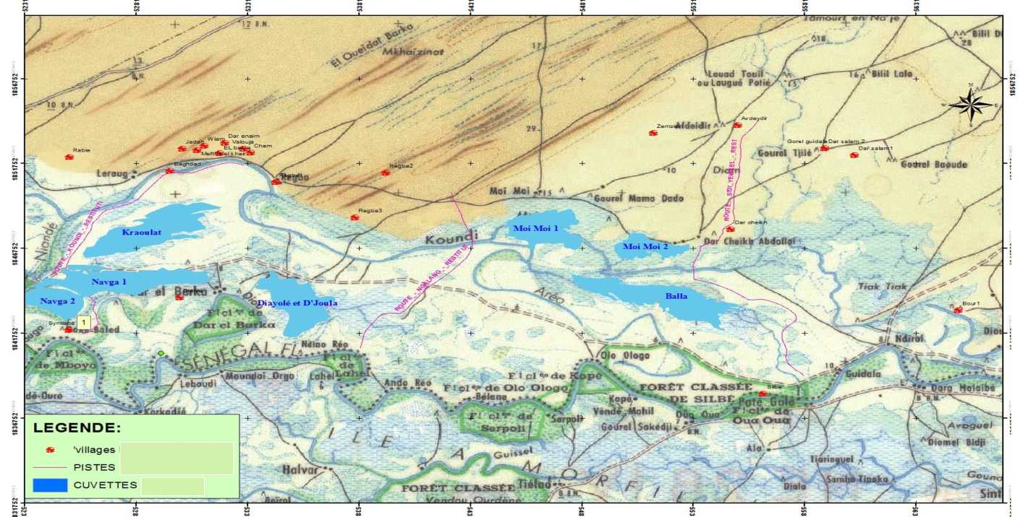

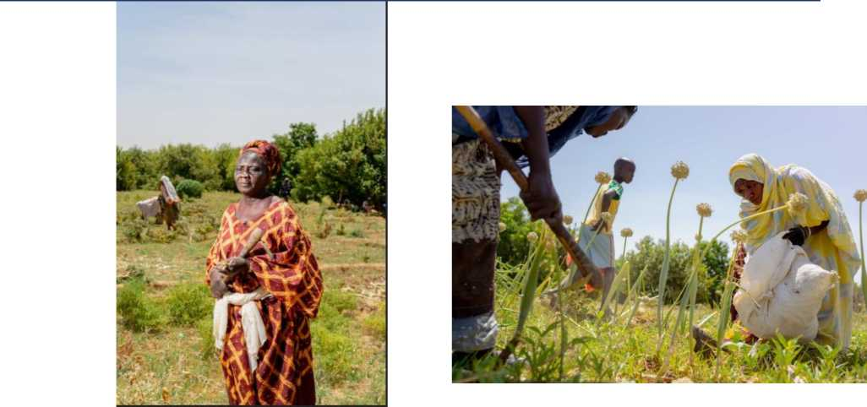

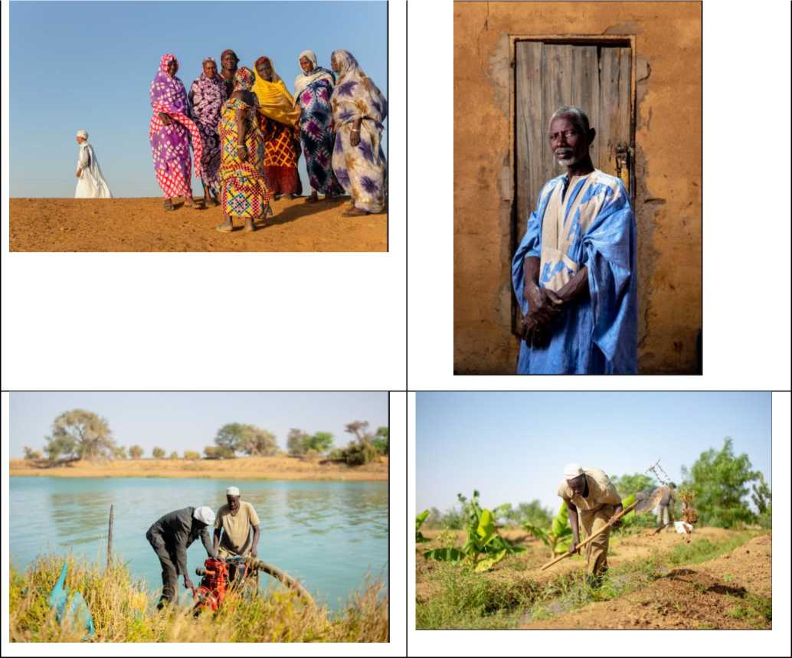

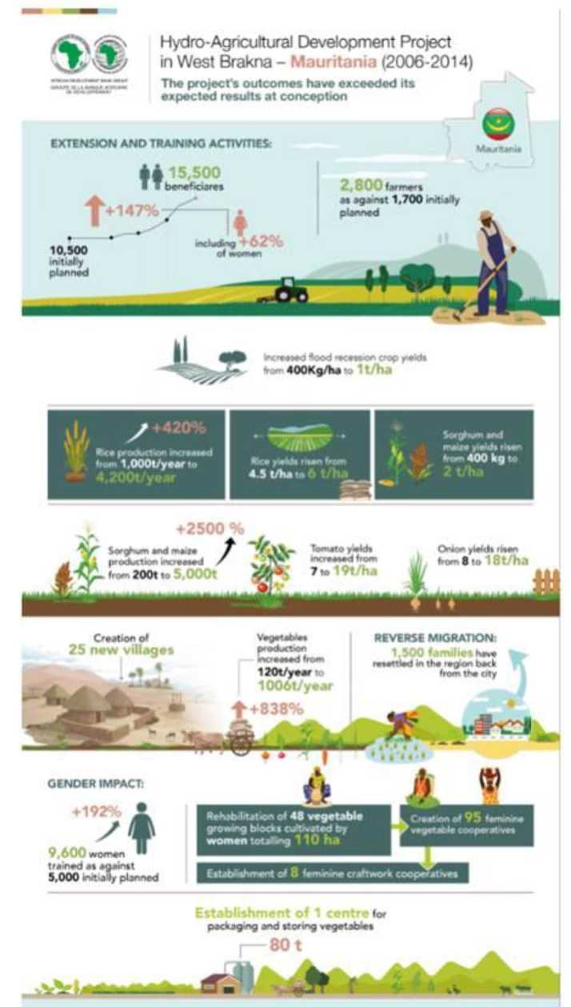

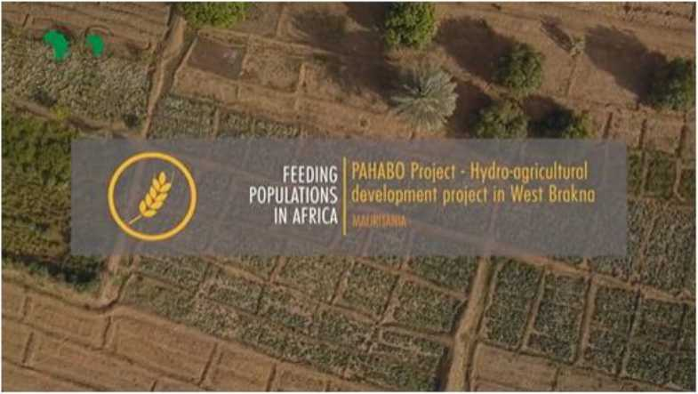

PAHABO documentary/movie link

French : [https://www.afdb.org/f7news-and-events/multimedia/video/pahabo-project-hydro-agricultural-](https://www.afdb.org/fr/news-and-events/multimedia/video/pahabo-project-hydro-agricultural-development-project-is-west-brakna-mauritania-1528) [development-project-is-west-brakna-mauritania-1528](https://www.afdb.org/fr/news-and-events/multimedia/video/pahabo-project-hydro-agricultural-development-project-is-west-brakna-mauritania-1528)

English : [https://www.afdb.org/en/news-and-events/multimedia/video/pahabo-project-hydro-agricultural-](https://www.afdb.org/en/news-and-events/multimedia/video/pahabo-project-hydro-agricultural-development-project-is-west-brakna-mauritania-1528) [development-project-is-west-brakna-mauritania-1528](https://www.afdb.org/en/news-and-events/multimedia/video/pahabo-project-hydro-agricultural-development-project-is-west-brakna-mauritania-1528)